Preparing Your JSTA Manuscript
Delete this guide page before submission. Replace all bracketed prompts, remove unused examples, and retain only references and displays used in your own work.
Review copy. Keep names, affiliations, ORCID identifiers, correspondence and identifying acknowledgments in the separate title page. Supply any identifying declarations confidentially to the editor. Do not enter author details in the running header.
Print layout. A4 with mirrored margins: 3.2 cm inside for binding, 2.3 cm outside, 2.6 cm top and 2.5 cm bottom. On odd pages the binding margin is left; on even pages it is right. Final trim and binding allowance must be agreed with the printer.
Journal typography. Body: Times New Roman 12 pt, 1.5 spacing. Abstract: 10.5 pt. Prompts: 11 pt. These print layout settings are JSTA house style. APA 7 governs headings, citations, references, tables and figures; this is not the default double spaced APA manuscript page format.
APA headings. Use unnumbered Title Case headings. Level 1 is centered and bold; Level 2 is left aligned and bold; Level 3 is left aligned, bold and italic. The opening section begins under the article title without an Introduction heading.
Tables and figures. Use separate sequences for Table 1, Table 2 and Figure 1, Figure 2. Graphs, charts, photographs and diagrams are all figures. Put the bold number and italic Title Case title above each display; place notes below it. Mention every display in the text before it appears.
References. Use author date citations, alphabetize the reference list, apply a 1.27 cm hanging indent, and verify every DOI. The reference list examples are real sources; use them only if cited in your manuscript. Do not copy example data as research findings.
Publication metadata. The companion publication first page contains author details, article history, DOI, volume, issue and page fields. These are completed and verified by the editor after acceptance. No ISSN, DOI or publication date is invented in this template.
Final anonymity check. Remove file author properties, comments, tracked changes, hidden text and identifiers in figures or supplementary files. Use anonymous repository links where necessary. Preserve accurate ethics and funding disclosures; provide full masked details separately.
Style authorities: apastyle.apa.org/style-grammar-guidelines/tables-figures and apastyle.apa.org/style-grammar-guidelines/references/examples. The publication metadata structure is informed by Scientific Reports article 10.1038/s41598-026-67203-8.

[Insert Your Article Title in Title Case]

Abstract
[Write 150–250 words covering the objective, methods or approach, principal findings with key estimates where appropriate, and the conclusion. Avoid citations and undefined abbreviations. Use a structured abstract only when appropriate to the study design. Do not include author identifiers.]
Keywords: [keyword one], [keyword two], [keyword three], [keyword four], [optional fifth], [optional sixth]

[Repeat Your Article Title Here]
[Introduce the problem, relevant literature, research gap and objectives or hypotheses. Explain the contribution. APA uses the article title rather than an Introduction heading for this opening section.]
[Citation format examples only: Grady et al. (2019) is a narrative citation with three or more authors. A two author parenthetical citation uses an ampersand (Rybaczewska & Sparks, 2022). Replace these examples with citations relevant to your work.]

Method

Study Design and Materials
[Describe the design, setting, participants or materials, eligibility, sampling, sample size rationale and data sources as applicable. Adapt the section structure to the article type.]

Procedure and Analysis
[Describe instruments, procedures, software versions, outcomes, assumptions, missing data handling and analysis methods. Report effect sizes and uncertainty where relevant. Include reproducibility information.]

Ethical Considerations
[Report approval or exemption and relevant consent. Mask only identity revealing details and provide complete information confidentially to the editor.]

Results
[Report findings in relation to the objectives, with sample sizes, units, estimates and uncertainty. Identify all tables and figures in the text. The following sentences demonstrate display callouts only; the display values are illustrative.]
[Example callouts: Table 1 summarizes the descriptive statistics. Table 2 presents the illustrative correlations. Figure 1 compares performance scores between conditions, and Figure 2 illustrates the record selection process.]

Discussion

Interpretation and Implications
[Interpret the findings against the objectives and literature. Distinguish evidence from speculation and explain theoretical or practical implications.]

Limitations and Future Research
[Discuss bias, uncertainty, limitations and generalizability. Identify justified directions for future research.]

Conclusion
[Answer the objectives directly and avoid claims beyond the evidence.]

Declarations
Ethics Approval and Consent to Participate. [State approval or exemption and consent arrangements, or explain why they were not applicable. Send masked identifying details separately.]
Consent for Publication. [State whether consent to publish identifiable information or images was obtained, or explain that this is not applicable. Do not publish signed participant consent records.]
Data Availability. [Give a stable data and code location or explain access restrictions and procedures. Provide an anonymous review link if needed.]
Competing Interests. [Declare relevant financial and nonfinancial interests, or state accurately that none exist.]
Funding. [Identify support and the funder’s role, or state that no specific funding was received. Provide masked grant details separately.]
Generative AI Use. [Identify substantive AI use, the tool and version or access date, purpose and verification; otherwise state accurately that no substantive generative AI was used.]

References
[APA 7 examples follow in alphabetical order. Article titles use sentence case. Journal titles and volume numbers are italic; issue numbers are not. Book titles are italic. Remove examples that are not cited in your submitted manuscript.]
Grady, J. S., Her, M., Moreno, G., Perez, C., & Yelinek, J. (2019). Emotions in storybooks: A comparison of storybooks that represent ethnic and racial groups in the United States. Psychology of Popular Media Culture, 8(3), 207–217. https://doi.org/10.1037/ppm0000185
Jackson, L. M. (2019). The psychology of prejudice: From attitudes to social action (2nd ed.). American Psychological Association. https://doi.org/10.1037/0000168-000
Jerrentrup, A., Mueller, T., Glowalla, U., Herder, M., Henrichs, N., Neubauer, A., & Schaefer, J. R. (2018). Teaching medicine with the help of “Dr. House.” PLoS ONE, 13(3), Article e0193972. https://doi.org/10.1371/journal.pone.0193972
Rybaczewska, M., & Sparks, L. (2022). Ageing consumers and e-commerce activities. Ageing and Society, 42(8), 1879–1898. https://doi.org/10.1017/S0144686X20001932
[The examples demonstrate a journal article with page numbers, a book, an article with an article number and a two author article. In text, cite the book as Jackson (2019) and the article with an article number as Jerrentrup et al. (2018). These citations demonstrate format and imply no substantive research claim.]

Table 1
Descriptive Statistics for Illustrative Study Measures
Measure | n | M | SD | 95% CI for M
Performance score | 60 | 69.00 | 12.00 | [65.90, 72.10]
Study time (hours) | 60 | 4.50 | 1.20 | [4.19, 4.81]
Satisfaction score | 60 | 3.80 | 0.70 | [3.62, 3.98]
Note. All values are illustrative and do not represent study findings. Performance ranges from 0 to 100 and satisfaction from 1 to 5. CI = confidence interval; M = mean; SD = standard deviation. Intervals are illustrative 95% t intervals for the means.
[Use no vertical lines or cell grids. Retain only essential horizontal rules. Align decimal precision within columns and identify units in the stub or headings. For a table reproduced or adapted from another source, add an appropriate source and copyright or license attribution in the note.]

Table 2
Illustrative Correlations Among Study Measures
Variable | 1 | 2 | 3
1. Performance | —
2. Study time | .32* | —
3. Satisfaction | .41** | .28* | —
Note. N = 60. Values are illustrative Pearson correlations from a separate example, not research findings. Blank upper triangle cells avoid duplication; em dashes mark the diagonal.
*p < .05. **p < .01. Two tailed tests.

Figure 1
Mean Performance Scores by Instruction Condition
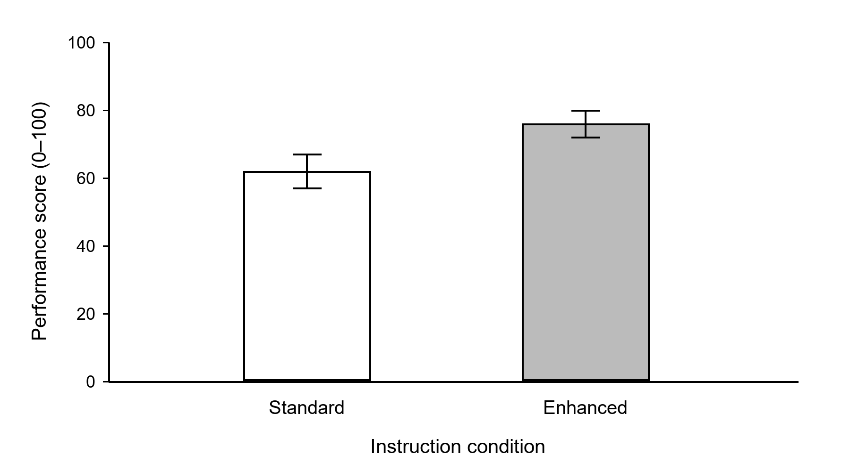
Note. All values are illustrative and are unrelated to the table examples. Bars show mean scores for Standard (M = 62) and Enhanced (M = 76) conditions; error bars represent illustrative 95% confidence intervals [57, 67] and [72, 80], respectively. Scores range from 0 to 100.
[Replace this graph with your own. State what error bars mean. Label axes and measurement units. Use legible sans serif labels at 8–14 pt at the final printed size. Distinguish series by shape, line style or pattern so meaning survives grayscale printing. Avoid 3D effects and decorative backgrounds.]
[For any adapted or reproduced display, place attribution in the note below the image and include the source in References. Attribution format example: Adapted from “Article title,” by A. A. Author and B. B. Author, Year, Journal Title, volume(issue), p. xx (DOI or URL). Copyright Year by [holder]. Adapted with permission. Use the applicable license statement instead when appropriate; do not claim permission unless obtained.]

Figure 2
Illustrative Record Selection Process
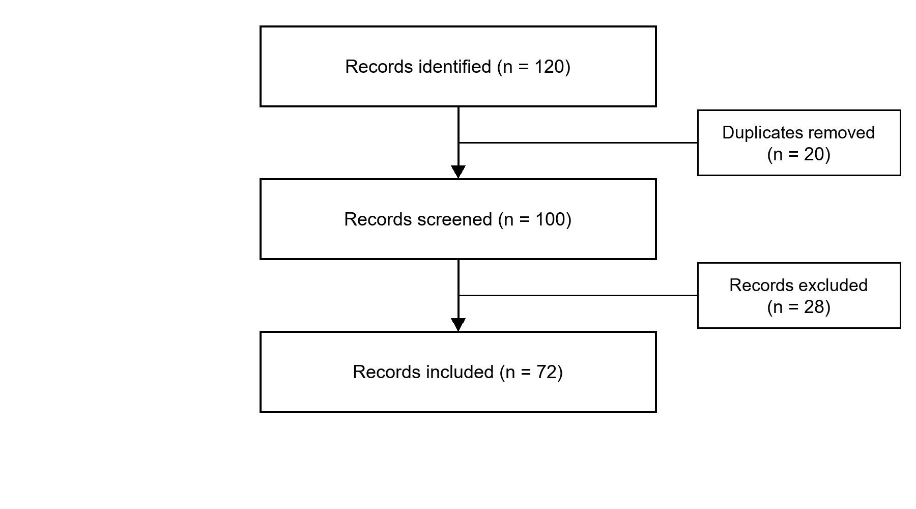
Note. Counts are illustrative: 120 records were identified, 20 duplicates removed, 100 records screened, 28 excluded and 72 included. This generic flowchart demonstrates figure formatting; it is not a complete PRISMA flow diagram.
[A chart, diagram, photograph or other illustration uses the same Figure number, italic title above the image and note below it. Number figures independently of tables. For a photograph, explain relevant labels and scale where needed and address permissions and consent where applicable.]
[Place each final table or figure after its first callout in the text, or on separate pages after References. This template groups examples for learning; remove examples that your paper does not need.]

